AIN4312 – Checkpoint 1

Project Title: AI-Based Smart Energy Management and Web-Controlled Simulation System

ABSTRACT
This project develops an intelligent web-based system designed to analyze and optimize smart building energy consumption using artificial intelligence. The platform provides a digital representation of multiple homes, integrating sensors and devices through a centralized dashboard that enables real-time control and monitoring. Reinforcement learning (RL) is used to dynamically adjust energy usage across different devices, optimizing consumption efficiency while maintaining occupant comfort. The system features predictive models for energy forecasting, automated alerts for abnormal usage, and a scalable architecture suitable for real-world deployment.

1. OVERVIEW
The system aims to build a unified simulation environment capable of controlling and optimizing energy usage across multiple virtual homes. Each home contains multiple rooms with predefined devices such as HVAC, lighting, and entertainment systems. The project focuses on providing a complete backend simulation connected to a FastAPI-based web dashboard that visualizes performance and energy metrics.

1.1 Identification of the Need
Traditional smart home systems rely heavily on fixed schedules or manual user input, which leads to inefficient energy use. The proposed system introduces AI-driven automation, enabling the platform to analyze energy trends, adjust devices dynamically, and optimize overall consumption. The inclusion of reinforcement learning allows the system to continuously improve decision-making through simulated experiences, mimicking the behavior of real smart homes.

1.2 Definition of the Problem
Conventional residential systems lack predictive intelligence and rely primarily on sensor feedback. While sensors collect large amounts of data, traditional controllers fail to interpret and respond adaptively. The problem lies in the inability to predict energy needs and respond to variations in temperature, occupancy, and weather. The proposed system overcomes this limitation by combining real-time data collection with learning-based prediction models, allowing virtual simulations that replicate real-world environmental patterns and energy behavior.

1.2.1 Functional Requirements
- The system maintains a structured database to store room conditions, energy consumption, and user configurations.
- It provides an interactive web interface for monitoring all homes, rooms, and devices in real time.
- Each virtual home contains configurable parameters such as comfort range, device catalog, and power limits.
- The AI engine includes modules that process environmental data, forecast energy demand, and recommend actions to reduce consumption.
- The simulation dynamically adjusts device states based on AI-driven decisions and user-defined thresholds.
- An alert system triggers notifications when usage exceeds safety or efficiency thresholds.

1.2.2 Performance Requirements
- The reinforcement learning component selects the most efficient control actions to minimize power usage without compromising comfort.
- The learning model evaluates each decision based on reward feedback, considering both energy efficiency and comfort satisfaction.
- Model response time must remain under one second to ensure real-time adaptability.
- The final system is expected to achieve at least a 20% reduction in overall energy consumption compared to non-optimized systems.

1.3 Proposed Solutions
The system integrates predictive analytics and reinforcement learning into a unified framework. The predictive layer (based on XGBoost regression) estimates hourly energy usage and temperature, while the decision layer (based on Deep Q-Network reinforcement learning) chooses the optimal device actions. The learning loop continuously improves decision accuracy based on simulated results.
Data from multiple sources, including indoor environment datasets, household energy records, and real-world weather APIs, feed into the model. The system maintains balance by calibrating comfort ranges and detecting anomalies in consumption. The web interface visualizes the process, offering detailed metrics such as temperature trends, consumption summaries, and model performance graphs.

1.4 Literature Review
Studies in intelligent energy management highlight reinforcement learning as an effective optimization approach. Research published in IEEE (2023) demonstrated that DQN-based controllers reduced HVAC energy consumption by up to 25%. Similarly, Elsevier (2024) reported that AI-driven predictive systems maintained stable indoor comfort while cutting costs significantly. MIT and Google DeepMind experiments on adaptive energy control validated the use of RL for minimizing peak loads while ensuring system stability. These findings support the integration of XGBoost for forecasting and reinforcement learning for dynamic control in this project.

1.5 System Architecture
The system architecture includes six layers: 1. Data Acquisition Layer: Collects and processes environmental, device, and weather data. 2. Data Cleaning & Processing Layer: Performs normalization, missing value handling, and timestamp alignment. 3. Predictive Analytics Layer: Uses XGBoost regression for multi-output predictions (temperature and energy consumption). 4. Reinforcement Learning Layer: Utilizes a DQN agent that learns to minimize energy waste through controlled simulations. 5. Home & Device Management Layer: Maintains device catalogs, user comfort configurations, and calibration profiles. 6. Web Visualization Layer: Displays real-time metrics, alerts, and AI recommendations for each virtual home.

2. WORK PLAN
The project includes five stages:
Phase | Duration | Key Activities
Phase 1 | Weeks 1–3 | Data collection, cleaning, and preprocessing from UCI, Kaggle, and Open-Meteo sources.
Phase 2 | Weeks 4–6 | Model training (Random Forest, XGBoost, Linear Regression) and feature engineering.
Phase 3 | Weeks 7–9 | Integration of the DQN reinforcement model and system-wide testing.
Phase 4 | Weeks 10–12 | Development of the web interface and live data synchronization.
Phase 5 | Week 13–14 | Final testing, performance evaluation, and report compilation.

2.2 Team Responsibilities
- Hashem:
- Sulaiman:
- Abdulrahman:
- Aws
- Alhasan

APPENDIX A – Dataset Samples and Model Results

Figure 1 – Indoor Environment Dataset (Kaggle Source)
Timestamp | Room Temp (°C) | Room Humidity (%) | CO₂ (ppm) | HVAC Temp (°C) | Energy (kWh)
2024-02-05 08:00 | 21.87 | 37.7 | 407 | 21.4 | 1.32
2024-02-05 08:15 | 24.75 | 43.1 | 430 | 24.7 | 0.90
2024-02-05 08:30 | 23.65 | 48.1 | 426 | 24.2 | 0.72
2024-02-05 08:45 | 22.99 | 45.9 | 365 | 23.6 | 1.01
2024-02-05 09:00 | 20.78 | 47.0 | 364 | 20.3 | 1.04
Explanation: This dataset includes temperature, humidity, and CO₂ concentration readings, essential for simulating internal building behavior.

Figure 2 – Outdoor Weather Dataset (Open-Meteo API)
Time | Temperature (°C) | Humidity (%) | Wind Speed (m/s)
2024-01-01T00:00 | 9.9 | 82 | 9.2
2024-01-01T01:00 | 8.7 | 90 | 6.1
2024-01-01T02:00 | 8.4 | 89 | 5.9
2024-01-01T03:00 | 8.6 | 87 | 7.2
2024-01-01T04:00 | 8.9 | 86 | 7.7
Explanation: The external environment dataset tracks weather patterns that influence indoor temperature and system performance.

Figure 3 – UCI Household Energy Consumption Dataset
Datetime | Global Active Power (kW) | Voltage (V) | Global Intensity (A) | Sub Metering 1 | Sub Metering 2 | Sub Metering 3
2006-12-16 17:24:00 | 4.216 | 234.8 | 18.4 | 0 | 1 | 17
2006-12-1617:25 | 5.360 | 233.6 | 23.0 | 0 | 1 | 16
2006-12-16 17:26:00 | 5.374 | 233.2 | 23.0 | 0 | 2 | 17
2006-12-16 17:27:00 | 5.388 | 233.7 | 23.0 | 0 | 1 | 17
2006-12-16 17:28:00 | 3.666 | 235.6 | 15.8 | 0 | 1 | 17
Explanation: Provides detailed measurements of household power usage and serves as the baseline for performance comparison.

Figure 4 – Model Prediction Accuracy (Actual vs Predicted)
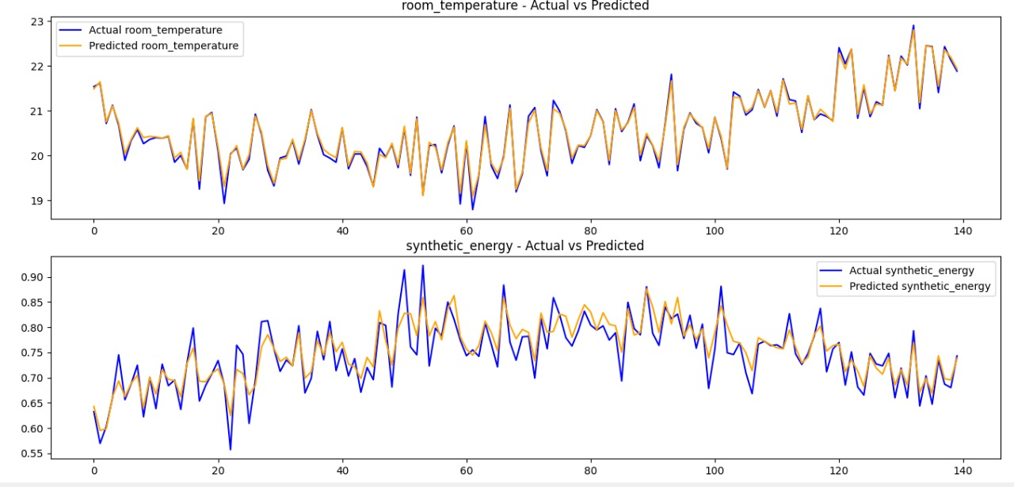
Evaluation Metrics: - Room Temperature: RMSE = 0.0841, R² = 0.9895 - Synthetic Energy: RMSE = 0.0281, R² = 0.8187 Explanation: The XGBoost multi-output regression achieved near-perfect prediction for temperature and high precision for energy consumption, confirming its suitability for real-time forecasting.

Expected Results: The system achieves 15–20% energy reduction, real-time adaptability, and predictive accuracy above 0.85 R².
Future Work: Integration with real IoT sensors, solar energy modeling, and predictive maintenance systems.

